For Entitlement

https://trailhead.salesforce.com/en/content/learn/modules/entitlement-management-for-lightning-experience/get-started-with-entitlements

Get Started with Entitlements

**Learning Objectives**

After completing this unit, you’ll be able to:

* Explain the value of using entitlements.
* Explain how to use entitlement templates.
* Create an entitlement for a customer.

**Introduction**

As Ursa Major Solar grows its solar panel empire, it wants to keep its reputation for top-notch, personalized service. Roberto Alvarez, COO and cofounder of Ursa Major, has heard some complaints lately that customers aren’t getting what they expect from their service level agreements (SLAs)—the contracts that spell out the level of service that Ursa Major is promising to customers. He decides that they need a better solution for keeping track of SLAs, so he turns to entitlement management in Salesforce.

Roberto learns that **entitlements** are units of customer support in Salesforce, such as phone support or web support. These entitlements are stated in each customer’s SLA. Some customers are entitled to daily phone calls with the support team, while other customers are more hands-off.

**Benefits of Salesforce Entitlements**

| **Benefit** | **Description** |
| --- | --- |
| Saves time for agents | Instead of manually looking up a customer’s entitlement, agents can see what type of support the customer is entitled to, right on the account page. |
| Automates routine tasks | By using entitlements with Apex triggers, agents can skip some of the rote tasks and spend their time doing impactful work for customers. |
| Defines support process | Instead of leaving the support process up to chance, define what steps agents should take, and when. This is great for agents who are still coming up to speed. |
| Offers better customer service | With all of your customers’ SLA information right up front, agents can give faster, more consistent support to customers. |

Roberto calls in admin Maria Jimenez to start setting up entitlements.  
  
To keep things simple, Maria decides to link entitlements to accounts in Salesforce. Here’s what her approach looks like.

1. Maria creates an entitlement that entitles a particular account to phone support.
2. A contact from that account calls Ursa Major’s support line with a question.
3. The support agent looks up the account and sees it has an active phone support entitlement.
4. The agent answers the question and, if needed, creates a case from the entitlement.

Now that she’s established the basics, it’s time for Maria to get into the details. When Ursa Major’s customers need support, it’s usually urgent—they can’t wait days for a response if their solar panels are broken. To address this issue, Maria creates **entitlement processes**, or customizable timelines that include all of the steps (or **milestones**, in Salesforce lingo) that support agents must complete to resolve a case. Once Maria sets an entitlement process up, she can apply it to multiple customer entitlements.

## Before You Set Up Entitlements

Before Maria can start creating entitlements, she logs in to Salesforce and takes care of a few things.

Note

#### Note

Launch your Trailhead Playground now to follow along and try out the steps in this module. To open your Trailhead Playground, scroll down to the hands-on challenge and click **Launch** . You also use the playground when it's time to complete the hands-on challenge.

1. Enable entitlement management.  
     
   * From Setup in Lightning Experience, enter Entitlement Settings in the Quick Find box, then click **Entitlement Settings**.
   * Select **Enable Entitlement Management**, and click **Save**.
2. Set field-level security for the Entitlement Name field on cases so you can view and edit it.  
     
   * From Setup, enter Field Accessibility in the Quick Find box, then click **Field Accessibility** | **Case** | **View by Fields**.
   * Select **Entitlement Name** in the dropdown menu, and click **Hidden** next to the System Administrator profile to display the accessibility options.
   * Under Field-Level Security, select **Visible**, and under Page Layout, select **Visible**, and click **Save**.
3. Add the Entitlement Templates related list to the product page layout.  
     
   * From the Object Manager, enter Product in the Quick Find box, then click **Product** | **Page Layouts** | **Product Layout**.
   * Select **Related Lists** from the menu.
   * Drag the Entitlement Templates related list into the Related Lists section.  
       
     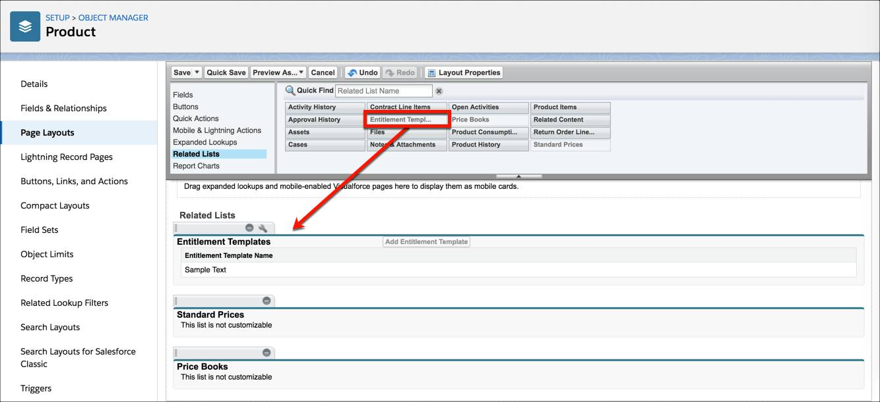
   * Click **Save**. If you’re asked whether you want to overwrite users’ related list customizations, click **Yes**.
4. Add the Entitlements related list to the account and asset page layouts.  
     
   * From the Object Manager, enter Account in the Quick Find box, then select **Account** | **Page Layouts** | **Account Layout**.
   * Select **Related Lists** from the menu at the top of the page.
   * Drag the Entitlements related list into the Related Lists section, and click **Save**.
   * From the Object Manager, enter Asset in the Quick Find box, then select **Asset**| **Page Layouts** | **Asset Layout**.
   * Drag the Entitlements related list into the Related Lists section, and click **Save**.

Now that Maria has all that set up, it’s time to create her first entitlement.

## Create an Entitlement

As we noted previously, a customer’s entitlement tells support agents what kind of support the customer is entitled to. One of Ursa Major’s top customers, DreamHouse Realty, has an SLA that entitles them to phone support for one year. Maria creates an entitlement that reflects the terms of the company’s SLA.

1. In the App Launcher, enter Entitlements in the search bar, then select **Entitlements**.
2. Click **New**.
3. Enter the following details:  
     
   * Entitlement Name: Standard Phone Support
   * Type: **Phone Support**
   * Account Name: DreamHouse Realty (You might have to create a new account—if you do, enter DreamHouse Realty as the name and leave the rest of the fields empty.)
   * Start date: Today’s date
   * End date: 1 year from today Leave the rest of the fields blank, and click **Save**.  
       
       
     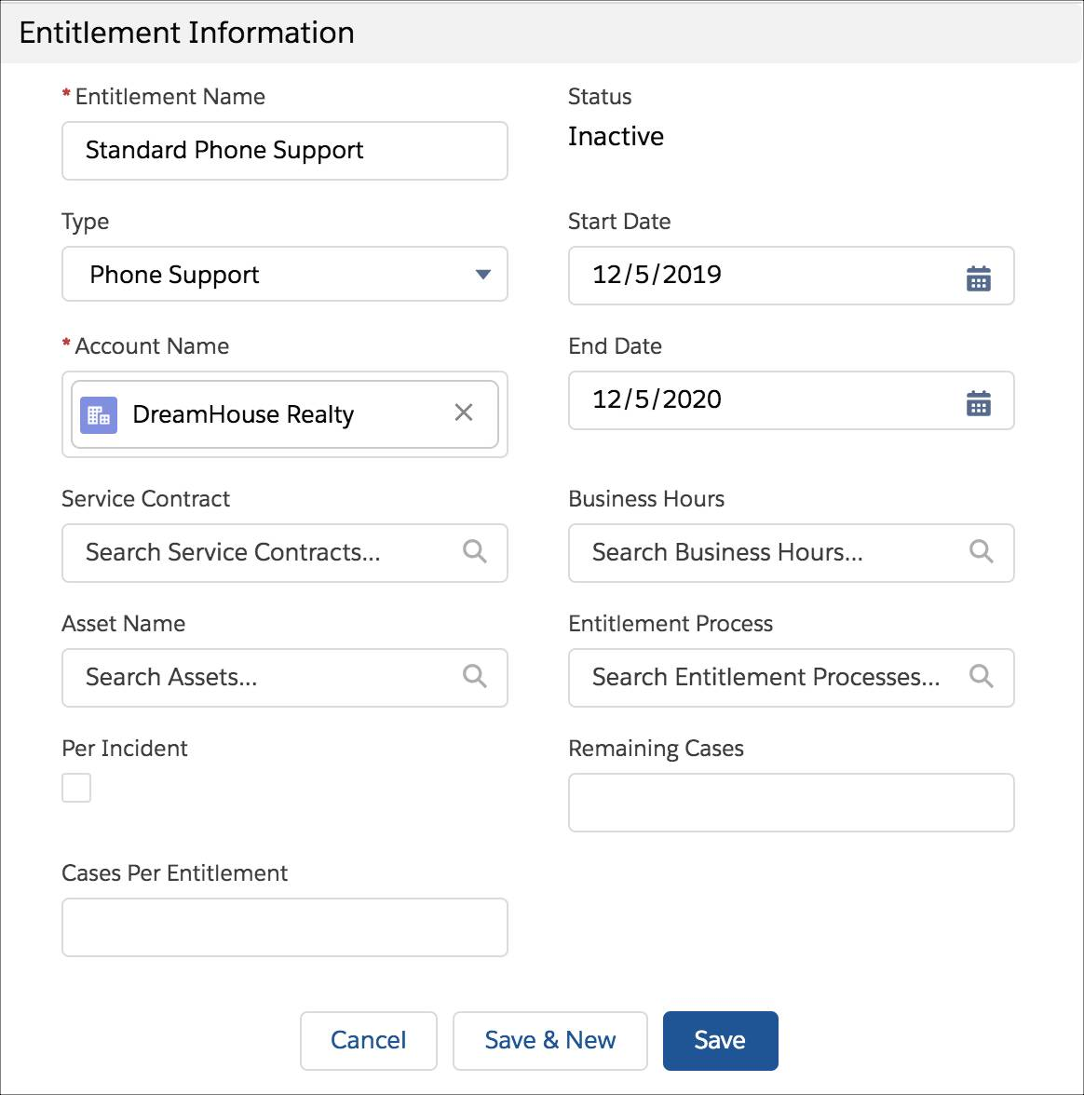

The DreamHouse Realty account now has its own entitlement that tells agents what support level its contacts are entitled to. Awesome! We’ll come back to DreamHouse Realty in a bit. But for now, let’s explore one way to create entitlements automatically in Salesforce.

## Using Entitlement Templates

All of Ursa Major’s products have a standardized SLA. For example, solar panels always include one year of phone support, no matter who’s buying them. Maria can manually create a separate “Phone Support” entitlement for every customer, but she has a job to do! To make things easier, Maria decides to attach **entitlement templates**to each product to predefine its support terms.

Note

#### Note

You only use entitlement templates if you use products in your org. Trailhead orgs come with several predefined products for you to play around with.

Solar panels are Ursa Major’s most popular product, so Maria decides to start there. Here’s how she uses an entitlement template to quickly entitle all solar panel owners to phone support.

1. Create an entitlement template.  
     
   * From Setup, enter Entitlement Templates in the Quick Find box, then select **Entitlement Templates**.
   * Click **New Template**.
   * Name the template Phone Support and use a term length of 365 days.
   * For now, leave the Entitlement Process field blank. (You can always add a process to your template once you create one.)
   * Leave the rest of the fields blank, and click **Save**.
2. Create the solar panel product.  
     
   * From the App Launcher, enter Products in the search bar, and select **Products**.
   * Click **New**.
   * For Product Name, enter Solar Panel.
   * For Product Code, enter 9876.
   * Select **Active**.
   * Leave the rest of the fields blank, and click **Save**.
3. Apply the entitlement template to the product.  
     
   * Switch to Salesforce Classic.
   * Navigate to the Solar Panel product page you just created. You can find it under Recent Items in the left-hand panel.
   * Click **Add Entitlement Template**.
   * Select the Phone Support template you created.
   * Click **Insert Selected**.
   * Click **Done**. Your template is now linked to your product!
   * Switch back to Lightning Experience.

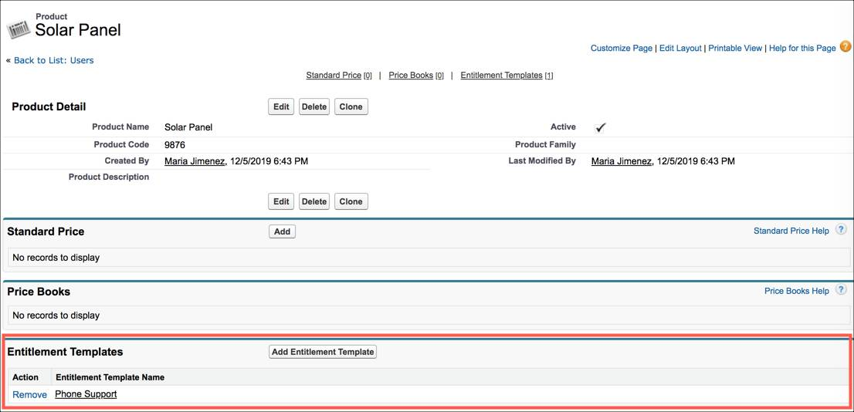

Whenever someone purchases solar panels from Ursa Major, an asset record is created from the Solar Panel product record. (Assets in Salesforce represent specific purchased products—for instance, “the solar panels purchased by DreamHouse Realty”). Because the product record now includes an entitlement template, a Phone Support with the same settings as the template is automatically added to the newly created asset. The entitlement appears in the Entitlements related list on the asset.

Let’s create an asset record for DreamHouse Realty.

1. In the App Launcher, search for Assets and select **Assets**.
2. Click **New**.
3. Enter the following information:  
     
   * Asset Name: DreamHouse Realty Solar Panel
   * Account: DreamHouse Realty
   * Product: Solar Panel
   * Install date: Today’s date Status: Installed  
     Leave the rest of the fields blank and click **Save**.
   * 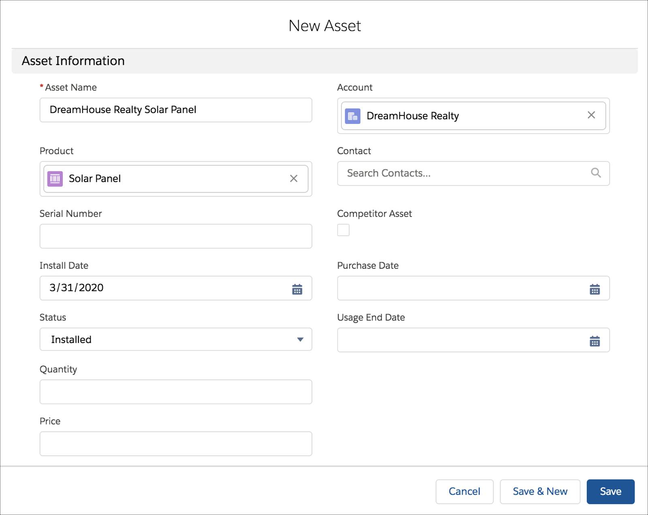

Let’s say DreamHouse Realty receives a faulty solar panel, and the company calls Ursa Major’s support line in a panic. The support agent quickly looks up DreamHouse Realty in Salesforce and finds the asset record for that solar panel. The agent sees from the Phone Support entitlement on the asset that DreamHouse Realty is entitled to phone support, and is able to order a replacement solar panel over the phone. Because of Maria, Ursa Major is able to stay true to its reputation for top-notch service.  
  
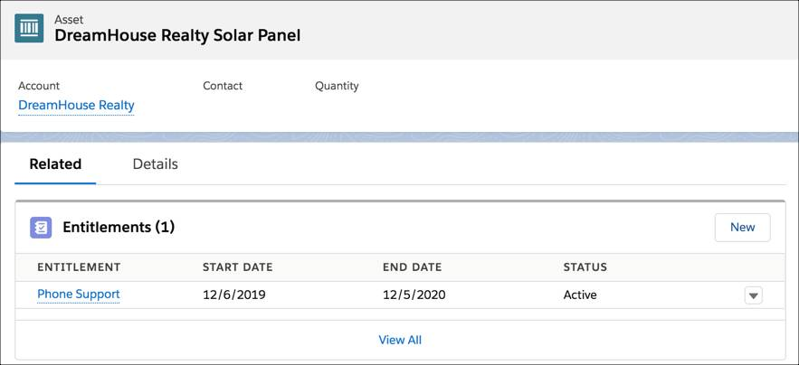

Custom Layout

https://trailhead.salesforce.com/content/learn/modules/lex_customization/lex_customization_page_layouts